Ayush Goyal
190905522 CSE D Roll 62

Computer Networks Lab 1

UDP Communication between Client and Server

We create a file called “udpser1.c” for server side connection ,the content of which is as follows :

// server program for udp connection

#include <stdio.h>
#include <strings.h>
#include <sys/types.h>
#include <arpa/inet.h>
#include <sys/socket.h>
#include<netinet/in.h>
#define PORT 5004
#define MAXLINE 1000

// Driver code
int main()
{
char buffer[100];
char *message = "Hello Client";
int listenfd, len,n;
struct sockaddr_in servaddr, cliaddr;
bzero(&servaddr, sizeof(servaddr));

// Create a UDP Socket
listenfd = socket(AF_INET, SOCK_DGRAM, 0);
//servaddr.sin_addr.s_addr = htonl(INADDR_ANY);
servaddr.sin_addr.s_addr = inet_addr("127.0.0.1");
servaddr.sin_port = htons(PORT);
servaddr.sin_family = AF_INET;

// bind server address to socket descriptor
bind(listenfd, (struct sockaddr*)&servaddr, sizeof(servaddr));

//receive the datagram
len = sizeof(cliaddr);

n = recvfrom(listenfd, buffer, sizeof(buffer),0, (struct sockaddr*)&cliaddr,&len);
buffer[n] = '\0';
puts(buffer);
//getchar();

// send the response
//getchar();
sendto(listenfd, buffer, n, 0, (struct sockaddr*)&cliaddr, sizeof(cliaddr));
getchar();
close(listenfd);
}

We create a file called “udpcli1.c” for client side connection, the content of which is as follows :

// udp client driver program
#include <stdio.h>
#include <strings.h>
#include <sys/types.h>
#include <arpa/inet.h>
#include <sys/socket.h>
#include<netinet/in.h>
#include<unistd.h>
#include<stdlib.h>

#define PORT 5004
#define MAXLINE 1000

// Driver code
int main()
{
char buffer[100];
char *message = "Hello Server";
int sockfd, n,len;
struct sockaddr_in servaddr, cliaddr;

// clear servaddr
bzero(&servaddr, sizeof(servaddr));
//servaddr.sin_addr.s_addr = htonl(INADDR_ANY);
servaddr.sin_addr.s_addr = inet_addr("127.0.0.1");
servaddr.sin_port = htons(PORT);
servaddr.sin_family = AF_INET;

// create datagram socket
sockfd = socket(AF_INET, SOCK_DGRAM, 0);

sendto(sockfd, message, MAXLINE, 0, (struct sockaddr*)&servaddr, sizeof(servaddr));
len=sizeof(cliaddr);
//getchar();
// waiting for response
n=recvfrom(sockfd, buffer, sizeof(buffer), 0, (struct sockaddr*)&cliaddr,&len );
buffer[n]='\0';
printf("message fromser is %s \n",buffer);
getchar();

// close the descriptor
close(sockfd);
}
When we compile and run the server program, it starts running and waits for the client side connection. Meanwhile when we compile and run the client program and connect the client side and send message, the server responds with appropriate message as shown in the screenshot below :

The overall picture :
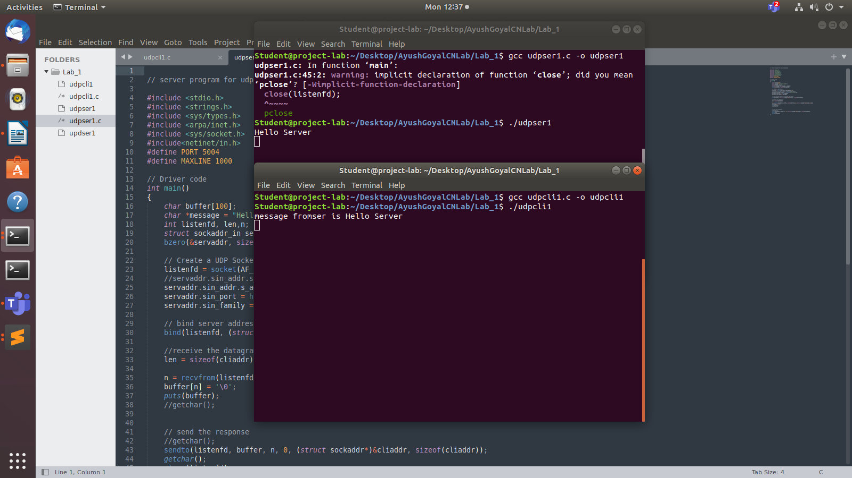
The Server Side :

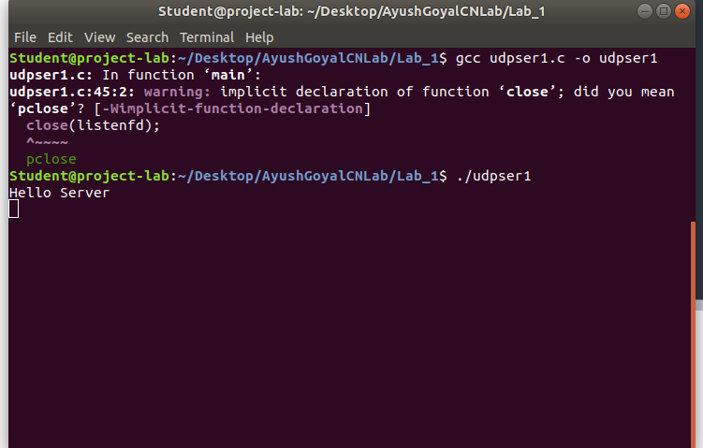

The Client Side :
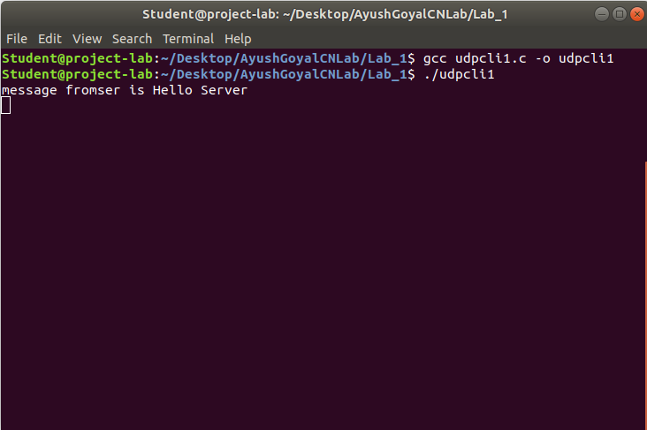

TCP Communication between Client and Server

We create a file called “tcpser1.c” for server side connection , the content of which is as follows:

#include <stdio.h>
#include <stdlib.h>
#include <unistd.h>
#include <errno.h>
#include <string.h>
#include <sys/types.h>
#include <sys/socket.h>
#include <netinet/in.h>
#include <netdb.h>
#include <arpa/inet.h>
#include <sys/wait.h>
#include <signal.h>
int main()
{
int sd,nd,n,len,reult;
struct sockaddr_in seraddress, cliaddr;
char buf[256];
sd=socket(AF_INET, SOCK_STREAM,0);
seraddress.sin_family=AF_INET;
seraddress.sin_addr.s_addr=INADDR_ANY;
seraddress.sin_port=htons(10200);
bind(sd,(struct sockaddr*)&seraddress,sizeof(seraddress));
listen(sd,5);
len=sizeof(cliaddr);
nd=accept(sd,(struct sockaddr*)&cliaddr,&len);
n=read(nd,buf,sizeof(buf));
buf[n]='\0';
printf("Message from Client : %s\n",buf);
n=write(nd,buf,strlen(buf));
getchar();
close(nd);
close(sd);
}

We create a file called “tcpcli1.c” for client side connection, the content of which is as follows :

#include <stdio.h>
#include <stdlib.h>
#include <unistd.h>
#include <errno.h>
#include <string.h>
#include <sys/types.h>
#include <sys/socket.h>
#include <netinet/in.h>
#include <netdb.h>
#include <arpa/inet.h>
#include <sys/wait.h>
#include <signal.h>
int main()
{
int sd,nd,n,len,reult,n1;
struct sockaddr_in seraddress, cliaddr;
char buf[256], buf1[256];
sd=socket(AF_INET, SOCK_STREAM,0);
seraddress.sin_family=AF_INET;
seraddress.sin_addr.s_addr=INADDR_ANY;
seraddress.sin_port=htons(10200);
len=sizeof(seraddress);
connect(sd,(struct sockaddr*)&seraddress,len);
printf("Enter the message token : \n");
gets(buf);
n=write(sd,buf,strlen(buf));
n1=read(sd,buf1,sizeof(buf1));
buf1[n1]='\0';
printf("Message from server : %s\n",buf1);
getchar();
close(sd);

}

When we compile and run the server program, it starts running and waits for the client side connection. Meanwhile when we compile and run the client program and connect the client side, it asks us to send a message token. When we send a message token, the server responds with appropriate message as shown in the screenshot below :

The overall picture :

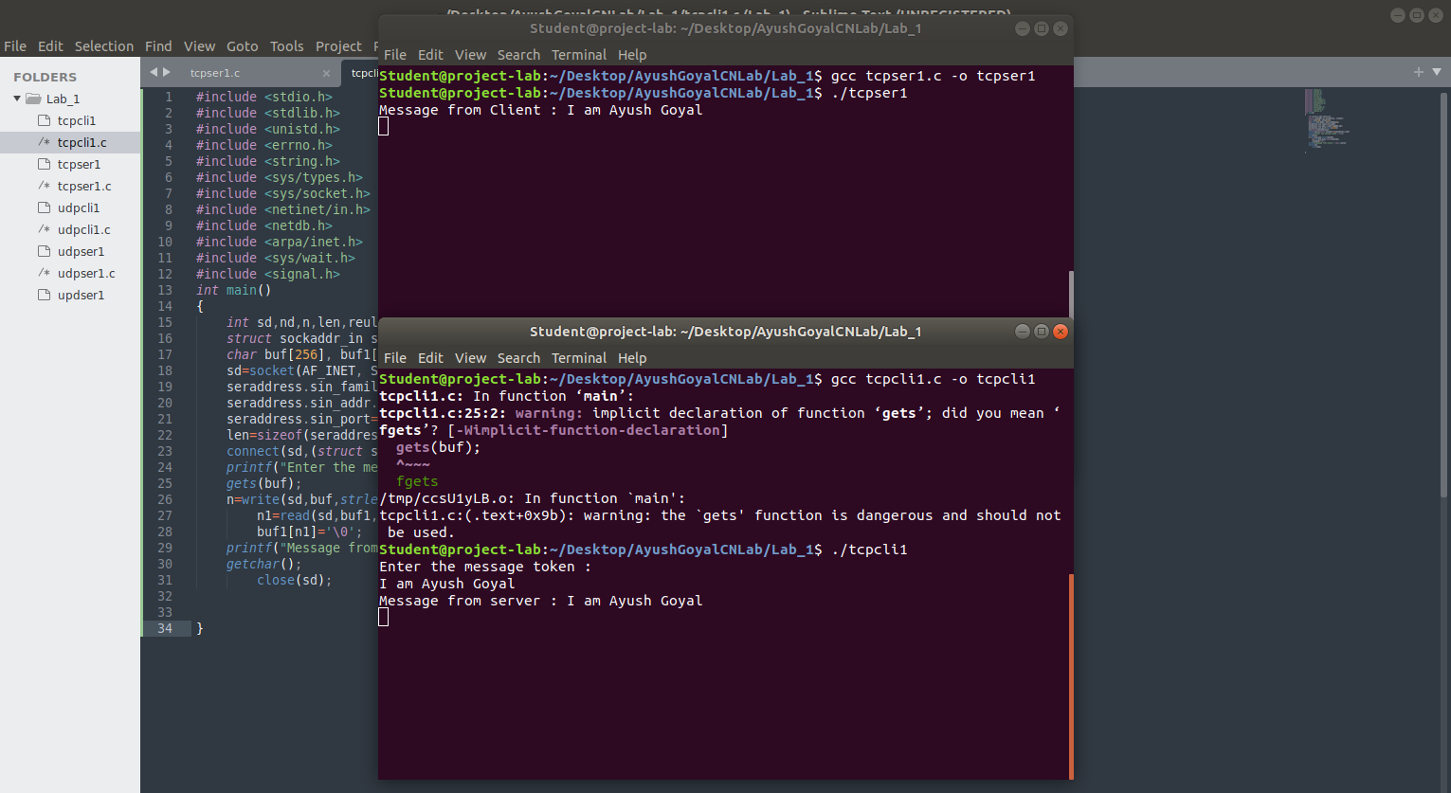
The Server Side :
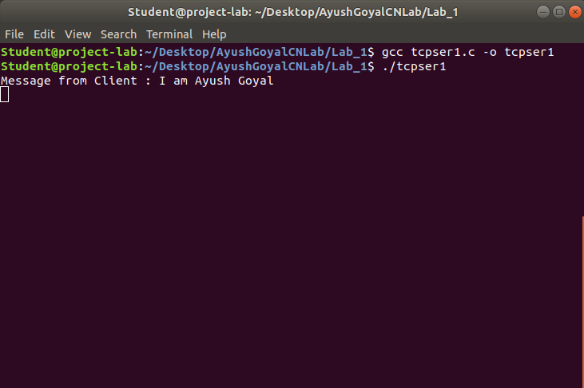

The Client Side :
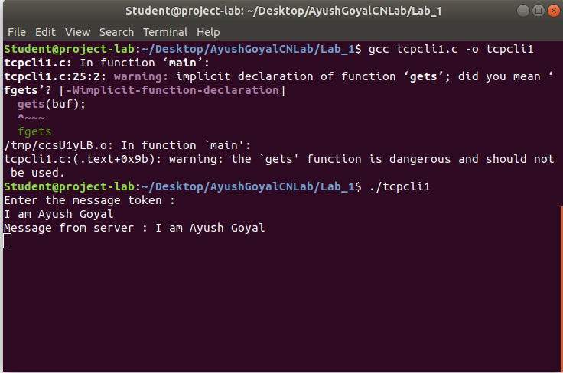

Above were the demonstrartion of both UDP and TCP client server communication protocols.

THE END

